|  |
| --- |
| Nanyang Polytechnic   Centre for IT Innovation  User Guide  For  Sea Transportation E Portal Services (STEPS)  Android & IOS  (For SAF Unit and Privileged users)  Version 0.1 |

@ Copyright Nanyang Polytechnic 2020

This copyright in this work belongs to Nanyang Polytechnic. The information contained in this work is confidential and must not be reproduced or disclosed to others without the prior written permission of Nanyang Polytechnic.

**DOCUMENT CONTROL**

|  |  |  |  |
| --- | --- | --- | --- |
| **Version** | **Date** | **Prepared By** | **Changes From Previous Version** |
| 0.1 | 08-Sep-2020 | Syahiirah Sulaiman | First Draft |

Table of Contents

1 Purpose 4

2 Getting Started 4

3 User Role 4

3.1 SAF Unit 4

4 FUNCTIONAL GUIDE 5

4.1 Login 5

4.2 Change Password 5

4.3 Forget Password 5

4.4 Home Page 5

4.5 Make Passenger Ferry Booking (one-time) 7

4.6 Make Passenger Ferry Booking (Recurring) 14

4.7 Make RPL Ferry Booking (one-time) 14

4.8 Make RPL Ferry Booking (Recurring) 14

4.9 Manage Bookings 18

4.9.1 View Upcoming Bookings 18

4.9.2 View Pending Bookings 18

4.9.3 View Rejected Bookings 18

4.9.4 View Past Bookings 18

4.9.5 View Details of a Booking 18

4.9.6 Cancel Booking 18

4.9.7 Report an Issue 18

4.9.8 Provide a Feedback 18

4.10 Announcements 18

4.10.1 View Announcements 18

4.10.2 Delete Announcement 18

4.11 Notifications 20

4.11.1 View Notifications 23

4.11.2 Filter Notifications 23

4.12 View User Account 23

# Purpose

This document provides step by step instructions on the features provided by Sea Transportation E Portal Services (STEPS) – Mobile.

# Getting Started

To start using STEPS – Mobile, it is recommended that your computer have the following settings:

* Android or IOS
* Screen resolution is 1024 by 768 pixels or more.

# User Role

For the mobile app, there will be 5 user roles, but this guide will only be for the SAF Unit and Privileged Users.

## SAF Unit

SAF Unit is one of the users of this mobile app. The SAF Units can access the following functions:

* Login
* Change Password
* Forget Password
* Home Page
* Make Passenger Ferry Booking (one-time)
* Make Passenger Ferry Booking (Recurring)
* Make RPL Ferry Booking (one-time)

Make RPL Ferry Booking (Recurring)

* Manage Bookings
* View and Delete Announcements
* View and Filter Notifications
* View User Account

# FUNCTIONAL GUIDE

## Login

## Change Password

## Forget Password

## Home Page

The Home Page shows all the bookings made by you, according to boarding date.

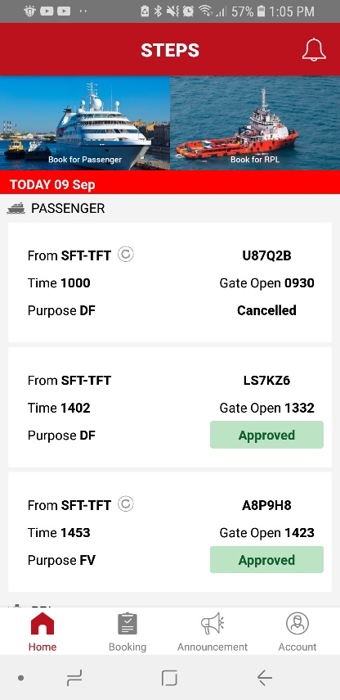

Figure .: Home Page

## Make Passenger Ferry Booking (one-time)

Step 1: On the ***Home*** page, click on ***Book for Passenger*** image.



Figure .: Passenger Booking

*Passenger Ferry Booking page will appear (Figure 4.5.2).*

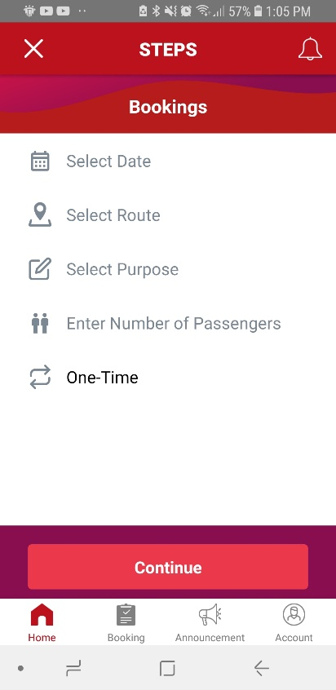

Figure .: Passenger Ferry Booking Page

Step 2: In the ***Select Date*** field, click on the field to enter the boarding date using a date picker.

Step 3: In the ***Select Route*** field, select the route.

Step 4: In the ***Select Purpose*** field, select the purpose of booking.

Step 5: In the ***Enter Number of Passengers*** field, enter the number of passengers.

Step 6: Click on the ***Continue*** button to view the available timings. (Figure 4.5.3)

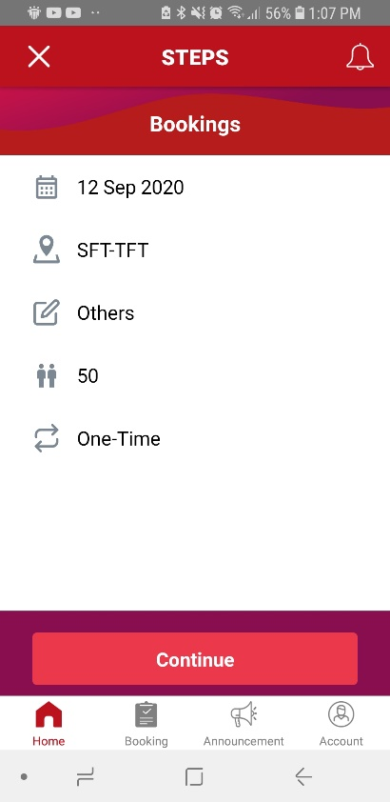

Figure .: Passenger Ferry Booking

Step 7: Select a ***Scheduled Timing*** or you may choose to ***Request for Other Timeslots. (***Figure 4.5.4 ***&*** Figure 4.5.5***)***

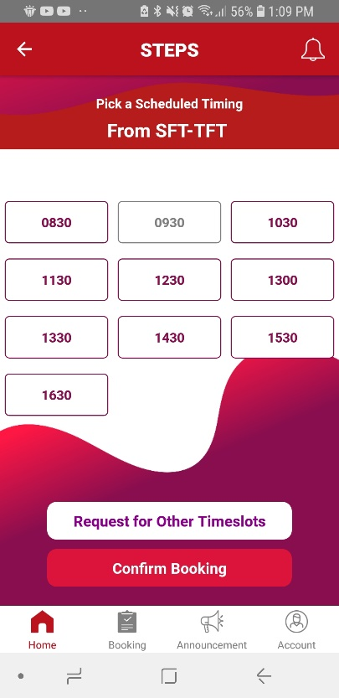

Figure .: Available Passenger Ferry Timings

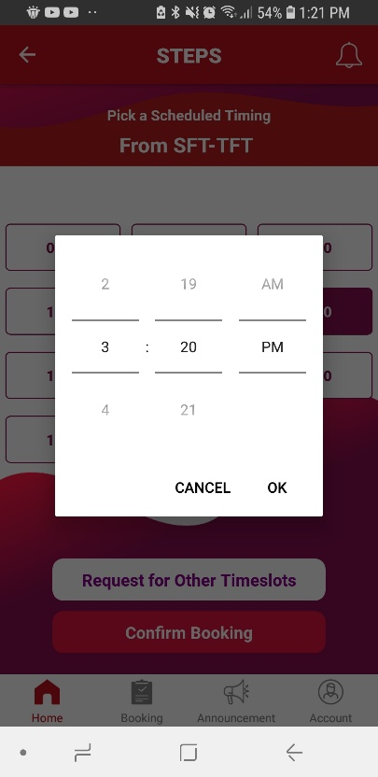

Figure .: Out of Schedule Timeslots

Step 8: In ***Booking Review***, review your booking to ensure all information are stated correctly.

Step 9: Click on the ***Confirm Booking*** button to complete your booking. ()

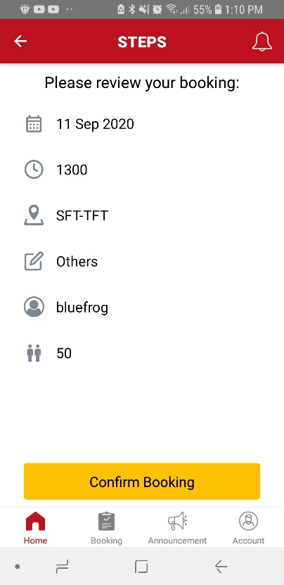

Figure .: Review Passenger Ferry Booking

A popup containing the status of the booking will appear (Figure 4.5.8).

Step 10: If an ***Ad-hoc*** ***Warning Message*** appear, you can click on the ***Yes, continue*** button if you still want to proceed. (Figure 4.5.7)

|  |
| --- |
| **Note:** This ***Warning Message*** appears when a booking is made less than 48 hours prior to the event. The warning will be shown to inform that ad-hoc charges will be incurred if booking is done.    Figure .: Ad-hoc Warning Message |

Step 10: Click OK. (Figure 4.5.8)

*You will be directed back to the Home page.*

|  |
| --- |
| **Note:** If your ***Performance Rating*** is more than 50% and booking is made more than 48 hours in advance, your booking will automatically be approved. Otherwise, bookings made must seek approval from the administrator.    Figure .: Passenger Ferry Booking Approval |

## Make Passenger Ferry Booking (Recurring)

This function is available for ***Privileged Users*** only.

Step 1: On the ***Home*** page, click on ***Book for Passenger*** image.



Figure .: Passenger Booking

Passenger Ferry Booking page will appear (Figure 4.6.2).



Figure .: Passenger Ferry Booking Page

Step 2: In the ***Select Date*** field, click on the field to enter the boarding date using a date picker.

Step 3: In the ***Select Route*** field, select the route.

Step 4: In the ***Select Purpose*** field, select the purpose of booking.

Step 5: In the ***Enter Number of Passengers*** field, enter the number of passengers.

Step 6: Click on **One-Time**, select Recurring. (Figure 4.6.3)



Figure .: Passenger Ferry Booking

Recurring Details fields will appear (Figure 4.6.4).

Step 7: In the ***Select Time*** field, choose the boarding time preferred by using a Time Picker.

Step 8: Click on ***Select Recurrence***. (Figure 4.6.4)

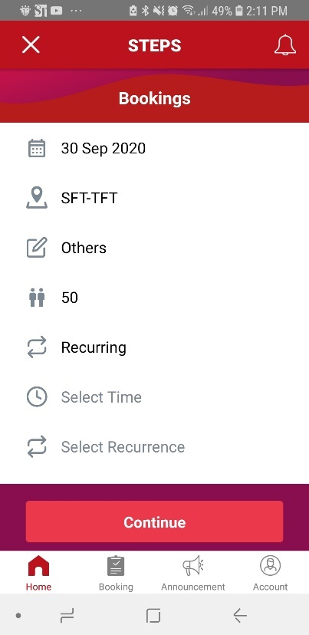

Figure .: Recurring Details

Recurring Settings page will appear (Figure 4.6.5).

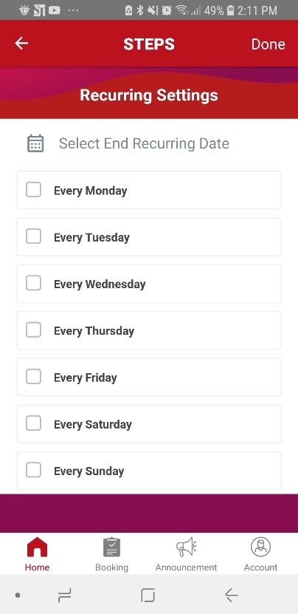

Figure .: Recurring Settings Page

Step 9: In ***Recurring Settings*** page, click on ***Select End Recurring Date*** to select the end date.

Step 10: In ***Recurring Settings*** page, tick on the checkbox to select the recurring days.

Step 11: Once complete, click ***Done***. (Figure 4.6.6)

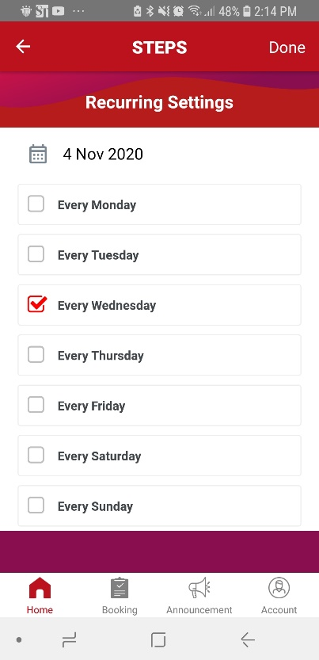

Figure .: Recurring Settings

You will return to the Passenger Ferry Booking page (Figure 4.6.7).

Step 12: Once all fields are filled in, click ***Continue***. (Figure 4.6.7)

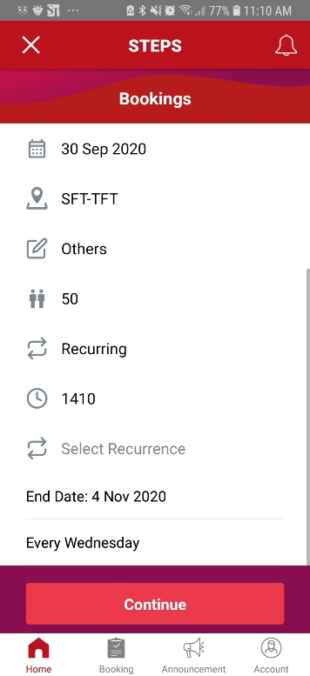

Figure .: Recurring Ferry Booking

Step 13: In ***Booking Review***, review your booking to ensure all information are stated correctly.

Step 14: Click on the ***Confirm Recurring Booking*** button to complete your booking. ()

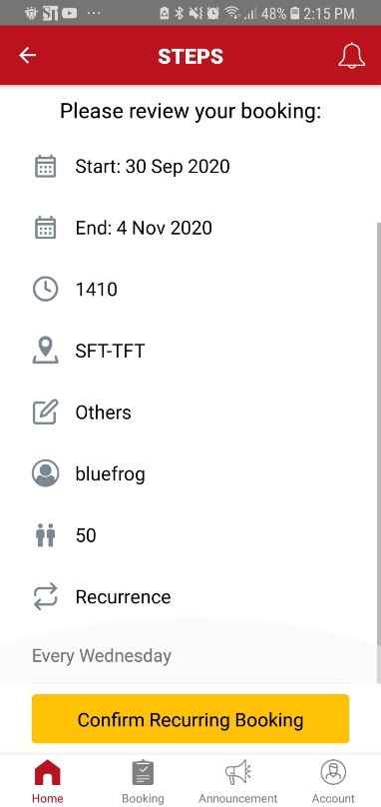

Figure .: Review Ferry Booking (Recurring)

A popup showing the status of the booking will appear (Figure 4.6.10).

Step 15: If an ***Ad-hoc*** ***Warning Message*** appear, you can click on the ***Yes, continue*** button if you still want to proceed. (Figure 4.6.9)

|  |
| --- |
| **Note:** This ***Warning Message*** appears when a booking is made less than 48 hours prior to the event. The warning will be shown to inform that ad-hoc charges will be incurred if booking is done.    Figure .: Ad-hoc Warning Message |

|  |
| --- |
| **Note:** If your ***Performance Rating*** is more than 50% and booking is made more than 48 hours in advance, your booking will automatically be approved. Otherwise, bookings made must seek approval from the administrator.    Figure .: Recurring Passenger Ferry Booking Approval |

Step 10: Click OK. (Figure 4.6.10)

*You will be directed back to the Home page.*

## Make RPL Ferry Booking (one-time)

Step 1: On the ***Home*** page, click on ***Book for RPL*** image.



Figure .: Home Page

*RPL Ferry Booking page will appear (*Figure 4.7.2*).*

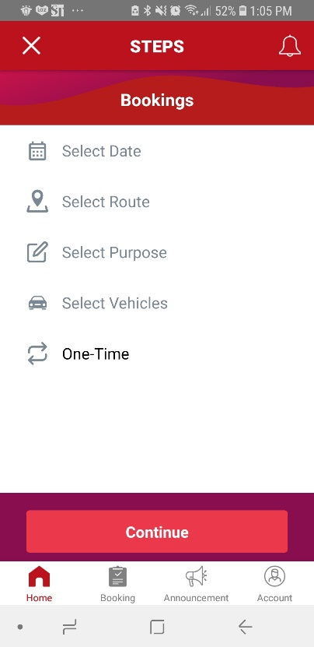

Figure .: RPL Ferry Booking Page

Step 2: In the ***Select Date*** field, click on the field to enter the boarding date using a date picker.

Step 3: In the ***Select Route*** field, select the route.

Step 4: In the ***Select Purpose*** field, select the purpose of booking.

Step 5: Click on the ***Select Vehicles*** field. (Figure 4.7.3)

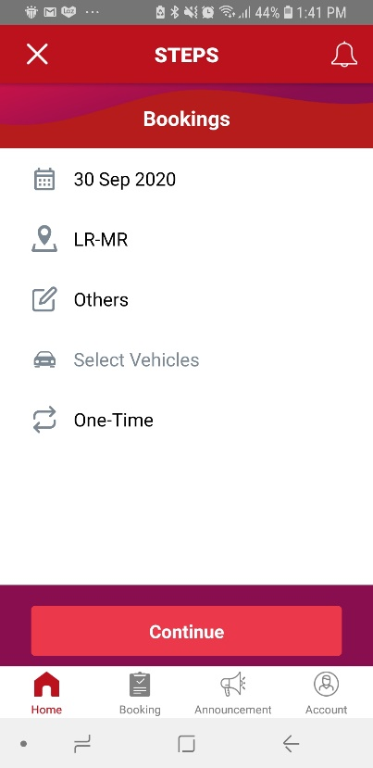

Figure .: RPL Ferry Booking

*Select Vehicles page will appear (*Figure 4.7.4*).*

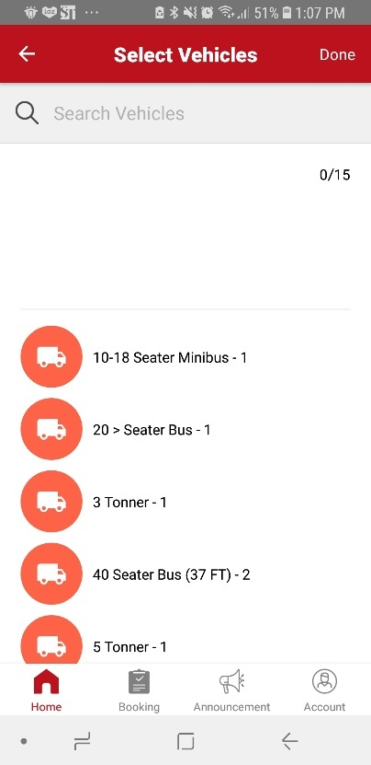

Figure .: Select Vehicles Page

Step 5: In the ***Select Vehicles*** page, find and select the vehicles that are to board the ferry.

Step 6: Click ***Done*** once vehicles are selected. (Figure 4.7.5)

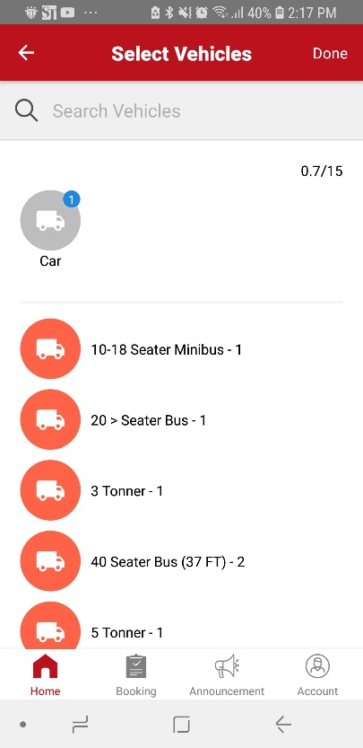

Figure .: Select Boarding Vehicles

*You will be directed back to the RPL Ferry Booking page (*Figure 4.7.6*).*

Step 7: Once all fields are filled in, click ***Continue***. (Figure 4.7.6)

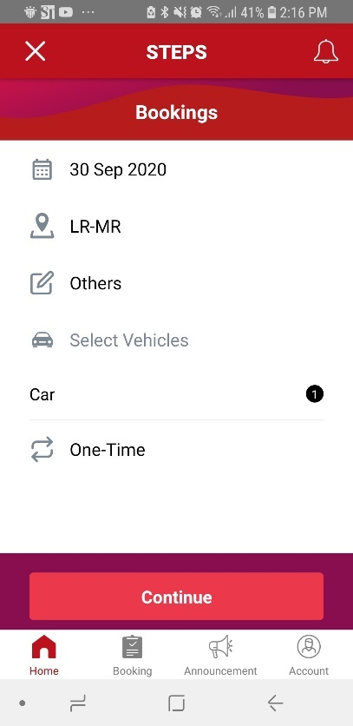

Figure .: RPL Ferry Booking

Step 7: Select a ***Scheduled Timing*** or you may choose to ***Request for Other Timeslots.*** (Figure 4.7.7& Figure 4.7.8)

Step 8: Click ***Confirm Booking***.

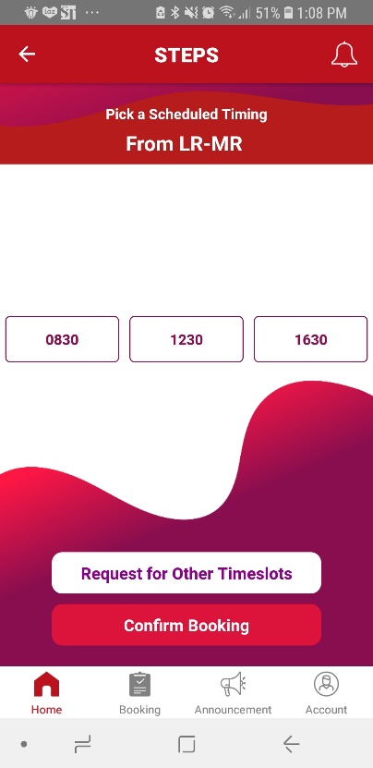

Figure .: Available RPL Ferry Timings

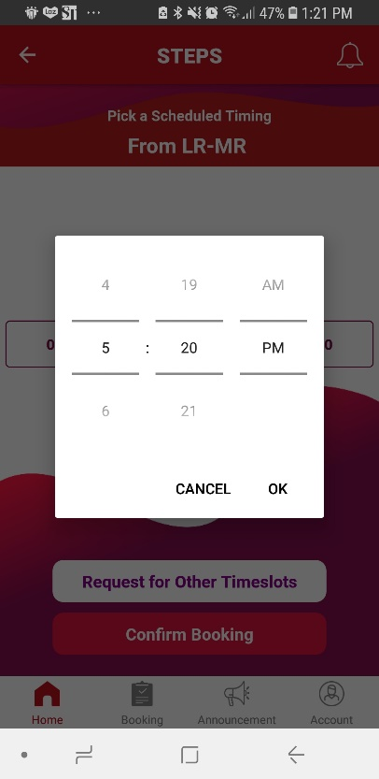

Figure .: Out of Schedule Timeslots

Step 9: In ***Booking Review***, scroll all the way down to enter the vehicle plate numbers in the ***Remark*** text field. (Figure 4.7.9)

Step 10: In ***Booking Review***, review your booking to ensure all information are stated correctly.

Step 11: Click on the ***Confirm Booking*** button to complete your booking. ()

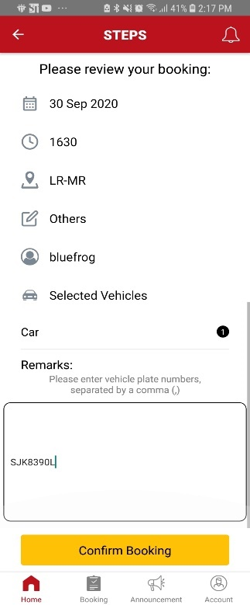

Figure .: Review RPL Ferry Booking

A popup containing the status of the booking will appear (Figure 4.7.11).

Step 10: If an ***Ad-hoc*** ***Warning Message*** appear, you can click on the ***Yes, continue*** button if you still want to proceed. (Figure 4.7.10)

|  |
| --- |
| **Note:** This ***Warning Message*** appears when a booking is made less than 48 hours prior to the event. The warning will be shown to inform that ad-hoc charges will be incurred if booking is done.    Figure .: Ad-hoc Warning Message |

Step 10: Click OK. (Figure 4.7.11)

*You will be directed back to the Home page.*

|  |
| --- |
| **Note:** If your ***Performance Rating*** is more than 50% and booking is made more than 48 hours in advance, your booking will automatically be approved. Otherwise, bookings made must seek approval from the administrator.    Figure .: RPL Ferry Booking Approval |

## Make RPL Ferry Booking (Recurring)

Step 1: On the ***Home*** page, click on ***Book for RPL*** image.



Figure .: Home Page

*RPL Ferry Booking page will appear (*Figure 4.8.2*).*



Figure .: RPL Ferry Booking Page

Step 2: In the ***Select Date*** field, click on the field to enter the boarding date using a date picker.

Step 3: In the ***Select Route*** field, select the route.

Step 4: In the ***Select Purpose*** field, select the purpose of booking.

Step 5: Click on the ***Select Vehicles*** field. (Figure 4.8.3)



Figure .: RPL Ferry Booking

*Select Vehicles page will appear (*Figure 4.8.4*).*



Figure .: Select Vehicles Page

Step 5: In the ***Select Vehicles*** page, find and select the vehicles that are to board the ferry.

Step 6: Click ***Done*** once vehicles are selected. (Figure 4.8.5)



Figure .: Select Boarding Vehicles

*You will be directed back to the RPL Ferry Booking page (*Figure 4.8.6*).*

Step 7: Click on **One-Time**, select Recurring. (Figure 4.8.6)

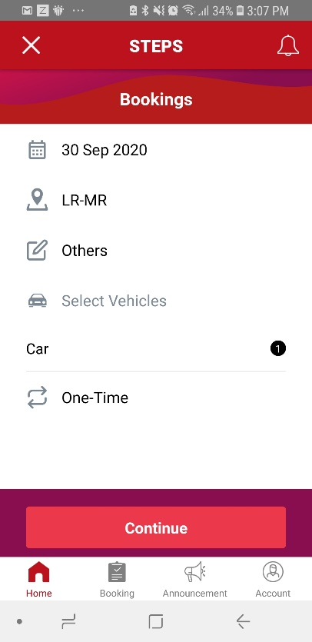

Figure .: Recurring RPL Ferry Booking

Step 8: In the ***Select Time*** field, choose the boarding time preferred by using a Time Picker.

Step 9: Click on ***Select Recurrence***. (Figure 4.8.7)

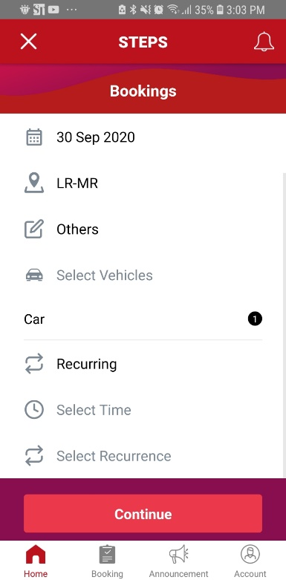

Figure .: Recurring RPL Ferry Booking

Recurring Settings page will appear (Figure 4.8.8).

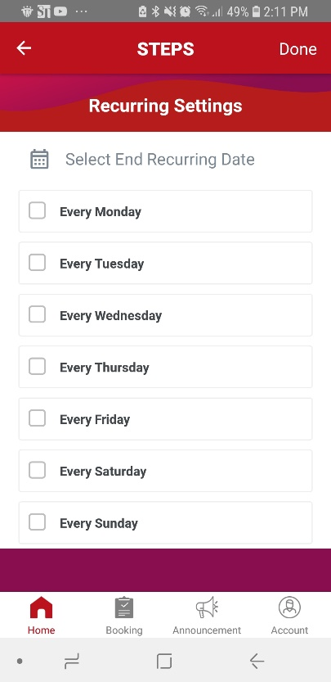

Figure .: Recurring Settings Page

Step 9: In ***Recurring Settings*** page, click on ***Select End Recurring Date*** to select the end date.

Step 10: In ***Recurring Settings*** page, tick on the checkbox to select the recurring days.

Step 11: Once complete, click ***Done***. (Figure 4.8.9)

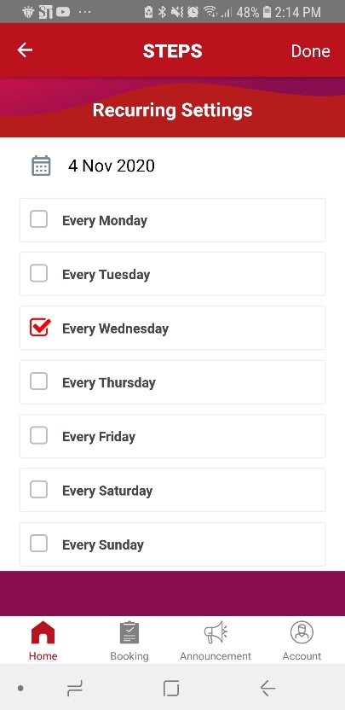

Figure .: Recurring Settings

You will return to the Passenger Ferry Booking page (Figure 4.8.10).

Step 12: Once all fields are filled in, click ***Continue***. (Figure 4.8.10)

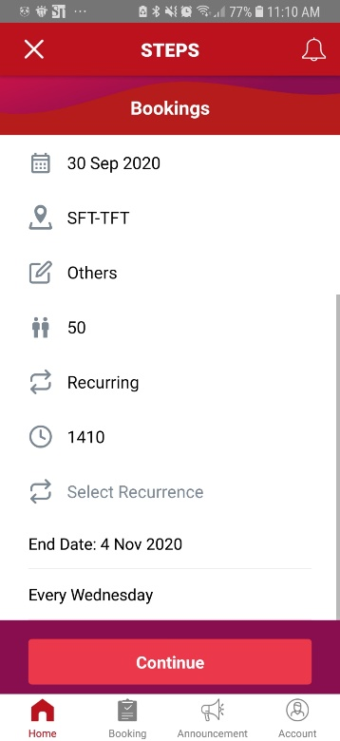

Figure .: RPL Ferry Booking

Step 13: In ***Booking Review***, scroll all the way down to enter the vehicle plate numbers in the ***Remark*** text field. (Figure 4.8.11)

Step 14: In ***Booking Review***, review your booking to ensure all information are stated correctly.

Step 15: Click on the ***Confirm Booking*** button to complete your booking. ()

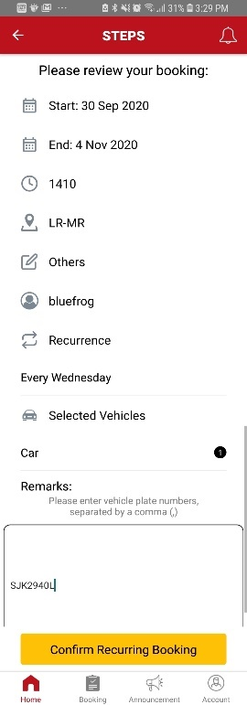

Figure .: Review RPL Ferry Booking

A popup containing the status of the booking will appear (Figure 4.8.13).

Step 16: If an ***Ad-hoc*** ***Warning Message*** appear, you can click on the ***Yes, continue*** button if you still want to proceed. (Figure 4.8.12)

|  |
| --- |
| **Note:** This ***Warning Message*** appears when a booking is made less than 48 hours prior to the event. The warning will be shown to inform that ad-hoc charges will be incurred if booking is done.    Figure .: Ad-hoc Warning Message |

Step 17: Click OK. (Figure 4.8.13)

*You will be directed back to the Home page.*

|  |
| --- |
| **Note:** If your ***Performance Rating*** is more than 50% and booking is made more than 48 hours in advance, your booking will automatically be approved. Otherwise, bookings made must seek approval from the administrator.    Figure .: RPL Ferry Booking Approval |

## Manage Bookings

### View Upcoming Bookings

Step 1: At the navigation bar located at the bottom of the screen, click on ***Booking***. (Figure 4.9.1.1)



Figure .: Home Page

You will be directed to your Bookings page, under the Upcoming tab. (Figure 4.9.1.2).

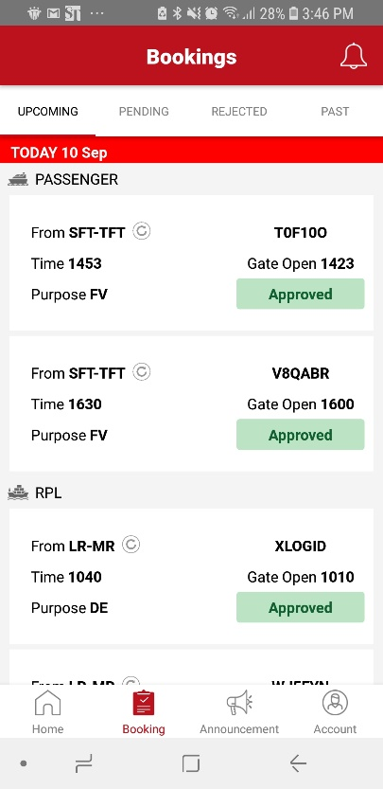

Figure .: Upcoming Bookings

### View Pending Bookings

Step 1: At the navigation bar located at the bottom of the screen, click on ***Booking***. (Figure 4.9.2.1)



Figure .: Home Page

You will be directed to your Bookings page, under the Upcoming tab. (Figure 4.9.2.2).

Step 2: To view ***Pending Bookings***, click on the tab ***Pending***.



Figure .: Upcoming Bookings Tab

All Pending Booking will be listed down. (Figure 4.9.2.3).

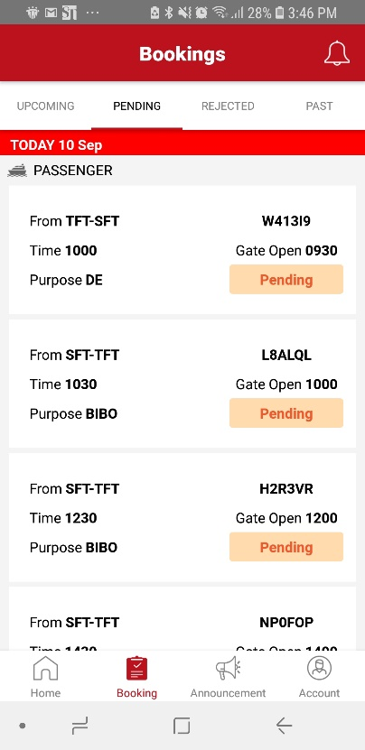

Figure .: Pending Bookings

### View Rejected Bookings

Step 1: At the navigation bar located at the bottom of the screen, click on ***Booking***. (Figure 4.9.3.1)



Figure .: Home Page

You will be directed to your Bookings page, under the Upcoming tab. (Figure 4.9.3.2).

Step 2: To view ***Rejected Bookings***, click on the tab ***Rejected***.



Figure .: Upcoming Bookings Tab

All Rejected Bookings will be listed down. (Figure 4.9.3.3).

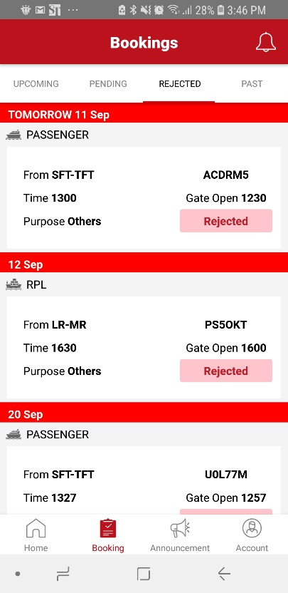

Figure .: Rejected Bookings

### View Past Bookings

Step 1: At the navigation bar located at the bottom of the screen, click on ***Booking***. (Figure 4.9.4.1)



Figure .: Home Page

You will be directed to your Bookings page, under the Upcoming tab. (Figure 4.9.4.2).

Step 2: To view ***Past Bookings***, click on the tab ***Past***.



Figure .: Upcoming Bookings Tab

All Past Bookings will be listed down. (Figure 4.9.4.3).

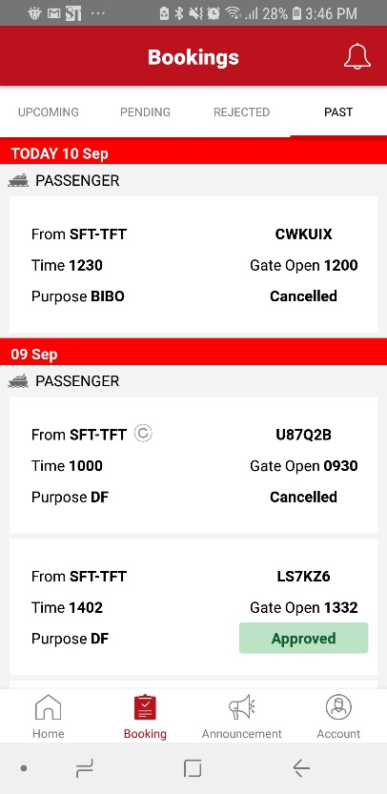

Figure .: Past Bookings

### View Details of a Booking

Step 1: Click on a particular ***Booking*** to view ***booking details***.



Figure .: Home Page

Booking Details page will appear (Figure 4.9.5.2).

**Tip:** You can click on ***Ferry Guidelines*** to read and find out what you need to take note of when boarding. *(*Figure 4.9.5.2*)*.

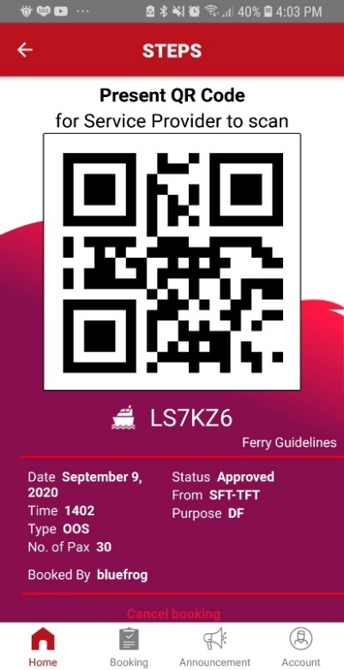

Figure .: Booking Details

### Cancel Booking

Step 1: In the ***Home*** page, click on any booking to cancel. (Figure 4.9.6.1)

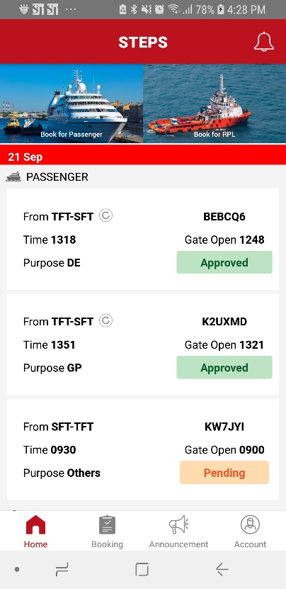

Figure .: Cancel Booking at Home Page

Booking Details page will appear (Figure 4.9.6.2).

Step 2: In ***Booking Details,*** scroll to the bottom of the page.

Step 3: Click on Cancel Booking. (Figure 4.9.6.2)

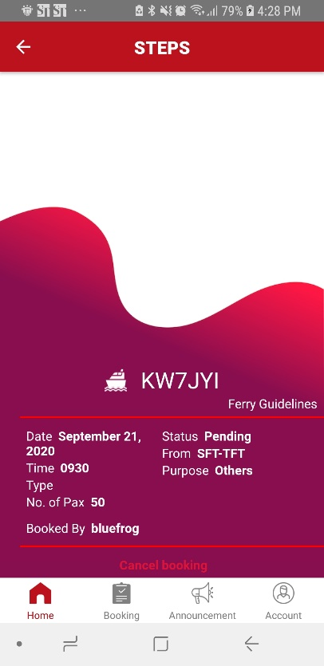

Figure .: Booking Details

You will be prompted to enter a reason for Cancellation (Figure 4.9.6.3).

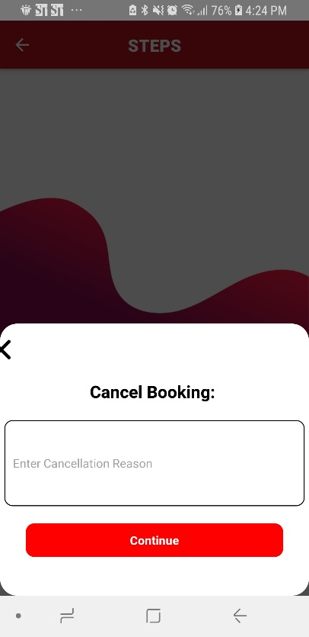

Figure .: Cancel Booking

Step 4: Enter the reason for ***Booking Cancellation*** in the textbox.

Step 5: Click ***Continue***. (Figure 4.9.6.4)

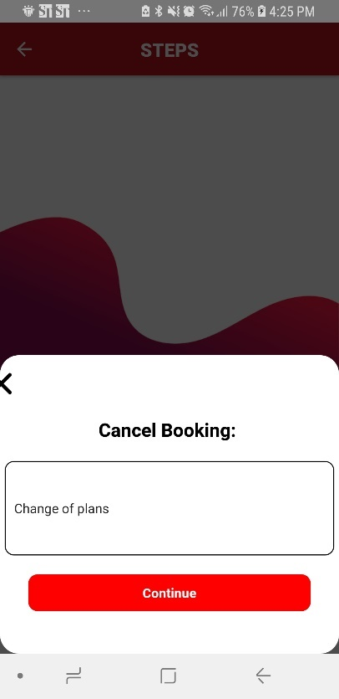

Figure .: Cancellation Reason

Step 6: Click ***OK*** to complete cancellation.

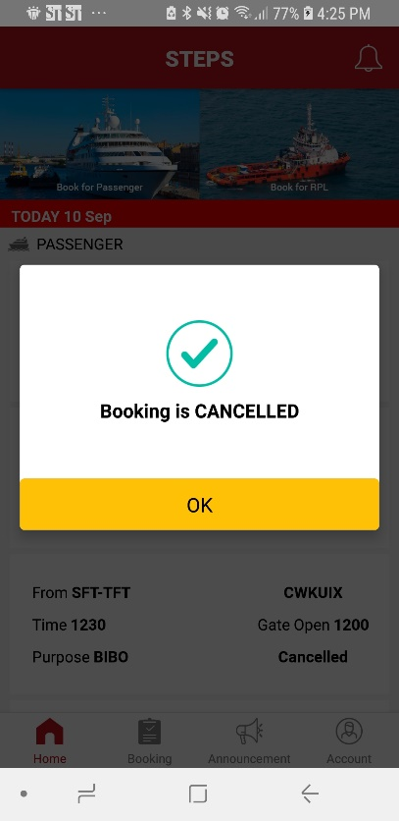

Figure .: Booking Cancellation Completed

You will be directed back to the Home page, there you can view the cancelled booking (Figure 4.9.6.6).

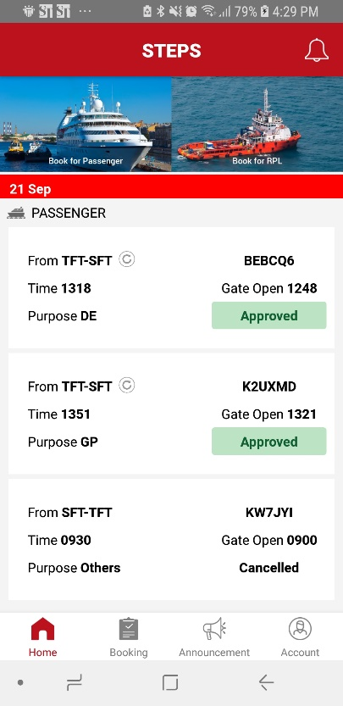

Figure .: View Booking Cancellation Status

### Report an Issue

### Provide a Feedback

## Announcements

### View Announcements

### Delete Announcement

Step 1: On the ***Administration*** menu bar, click on ***View/Update Profile,*** the user profile will automatically displayed*(Figure 4.4.1.1)*.

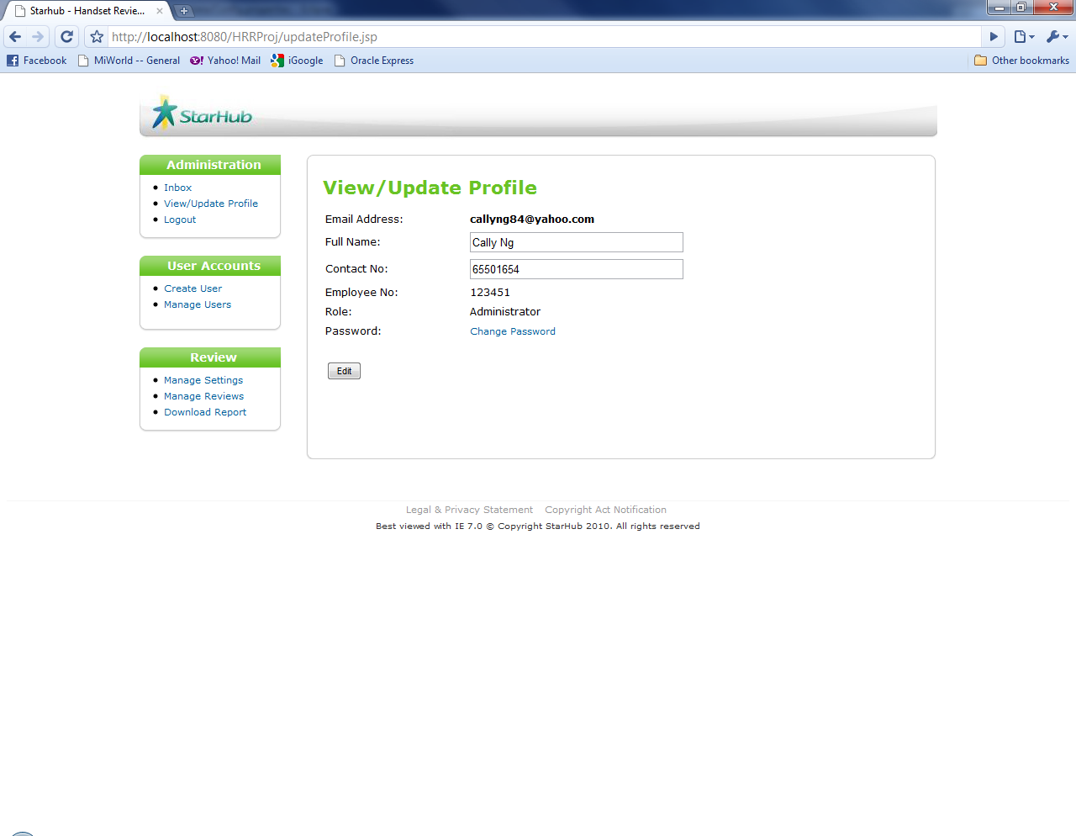

Figure 4.4.1.1: View/Update Profile page

## Notifications

This function allows the administrator to configure application setting for the following:

* Determine the review sorting order in the consumer review module. Administrator can choose to sort the review by review date in descending order or by rating in descending order.
* Threshold value of inappropriate reporting. For any review that was reported as inappropriate and exceed the threshold, system will set the particular review to red flag
* Blacklist keywords on the review comment. System will set a new review to blacklisted when it contain the blacklist keywords.

Step 1: On the ***Review*** menu bar, click on ***Manage Settings*** *(Figure 4.6.1)*.

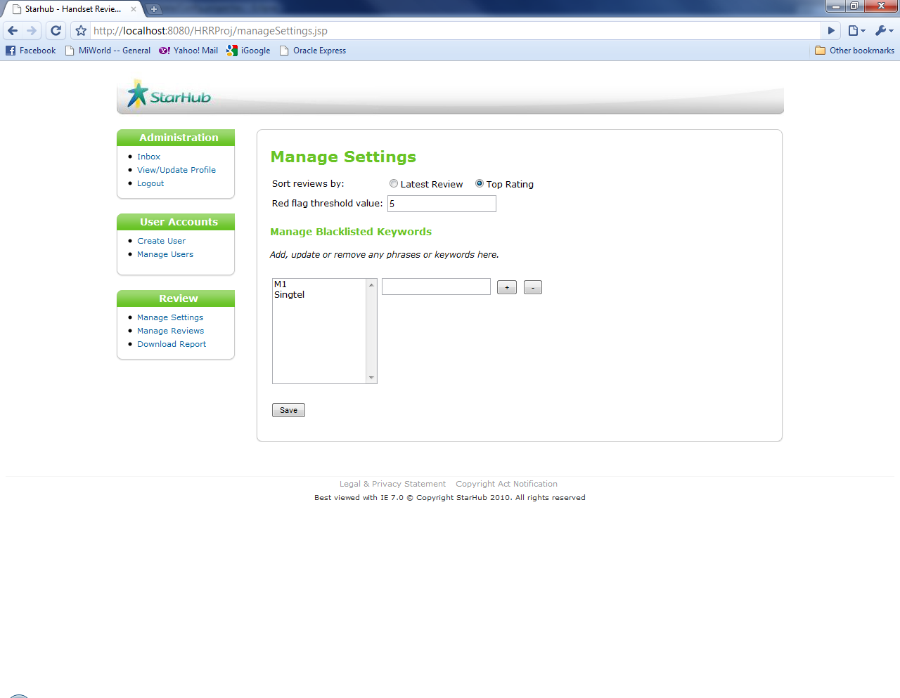

Figure 4.6.1: Manage Settings page

Step 2: In the ***Sort reviews by*** radio buttons, check required review sorting *order*.

Step 3: In the ***Red flag threshold value*** textbox, enter red flag threshold value

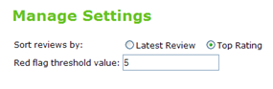

Figure 4.6.2: Manage Settings section

Step 4: In the ***Manage Blacklisted Keywords*** section, add, update or remove any phrases or keywords.

In the textbox, enter one phrase or keyword, click on the“***+***” sign button to add the phrase or keyword *(Figure 4.6.3)*.



Figure 4.6.3: “+” sign button

To remove the phrase or keyword, select the keywords in the list and click on the“***-***” sign button *(Figure 4.6.4)*.

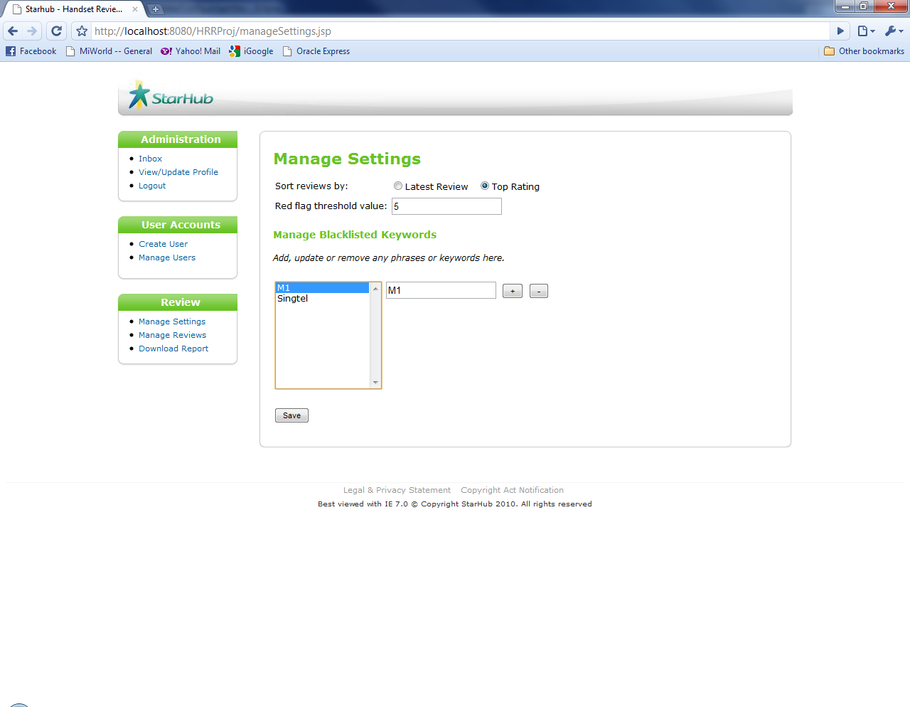

Figure 4.6.4: “-” sign button

Step 5: Click on ***Save*** button to save settings *(Figure 4.6.6)*.



Figure 4.6.6: Save Settings

Asuccessful update message will be shown (Figure 4.6.7).

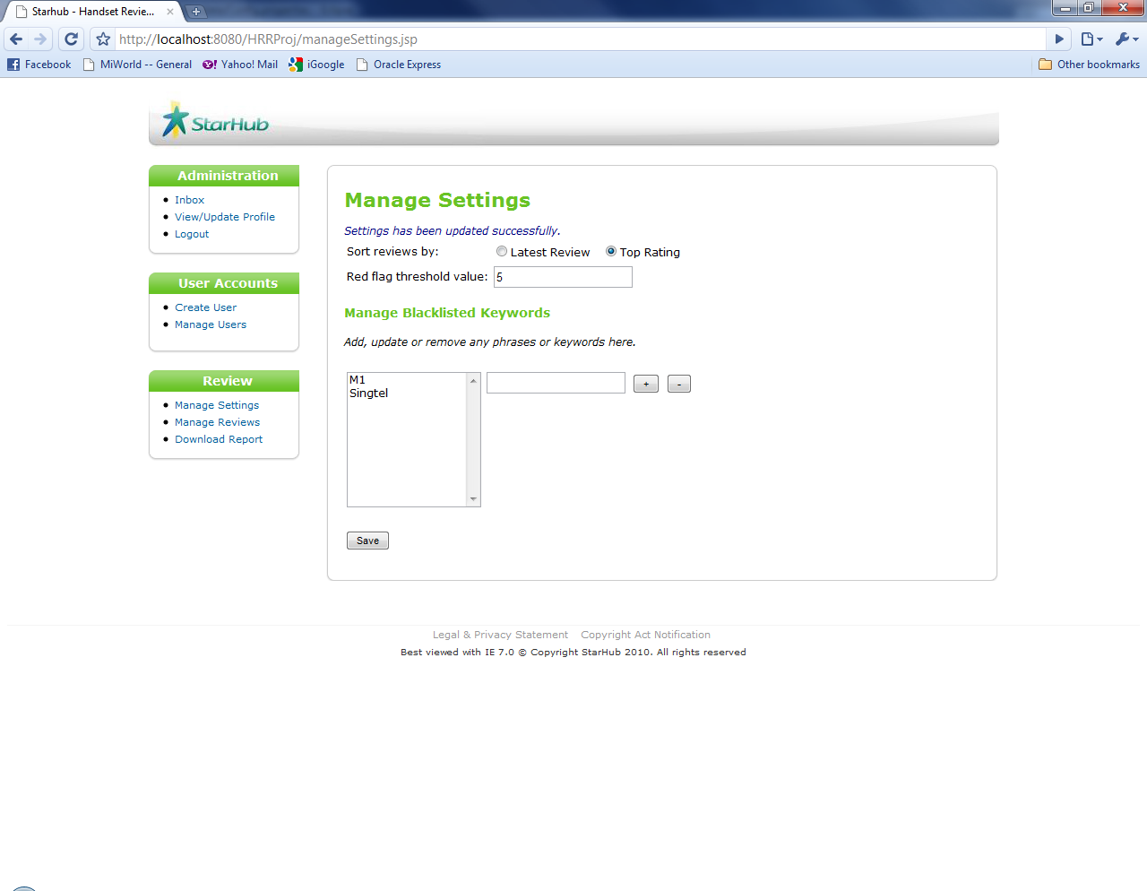

Figure 4.6.7: Successful Update of Settings message

### View Notifications

### Filter Notifications

## View User Account

This function allows the administrator to change the status and moderate the content of the reviews.

**END OF DOCUMENT**